https://verdemedia.com/blog/top-2016-industrial-and-manufacturing-website-designs/:
Top Website Designs of 2016: Industrial & Manufacturing Edition
By: Jon Teodoro
 |  |  |  |  |  | 
After reviewing hundreds of international industrial and manufacturing companies’ websites, we noticed that very few are taking a digital-driven approach to marketing themselves. Many websites that we came across looked like they came out of Microsoft Front Page 95. A tiny fraction of them had a responsive or dedicated mobile experience. This was very surprising, considering the fact that it is 2015.
Here are the top eight industrial and manufacturing website designs that caught our team’s eye.
To cycle through websites, click “Previous” or “Next”, or touch & drag left to right.
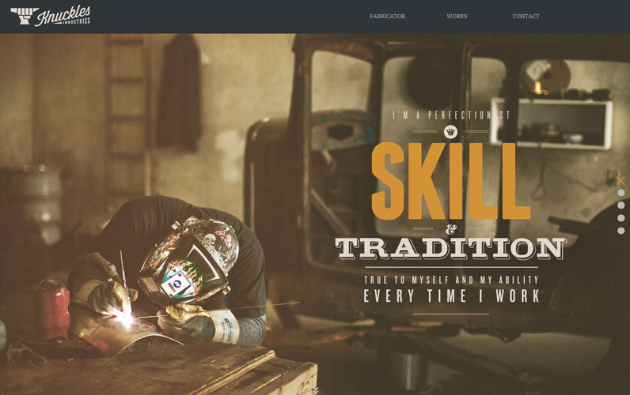
1 of 8: Knuckles Industries

What we like about it: Full page, full-width paralax design with vintage quality photos. Simply vontent architecture. (View site in new tab)
< PREVIOUS |  | NEXT >
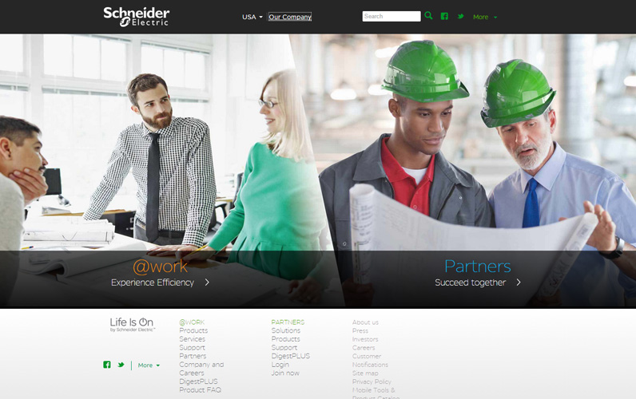
2 of 8: Schneider Electric

What we like about it: Clean and simple landing page which allows the visitor to choose where they need to go. (View site in new tab)
< PREVIOUS |  | NEXT >

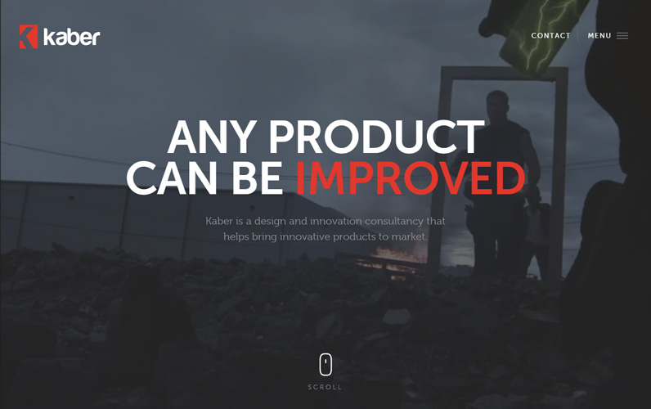
3 of 8: Kaber Technology

What we like about it: High-quality, professionally edited video background and full-sized photos and rendering with short, concise copy. (View site in new tab)
< PREVIOUS |  | NEXT >

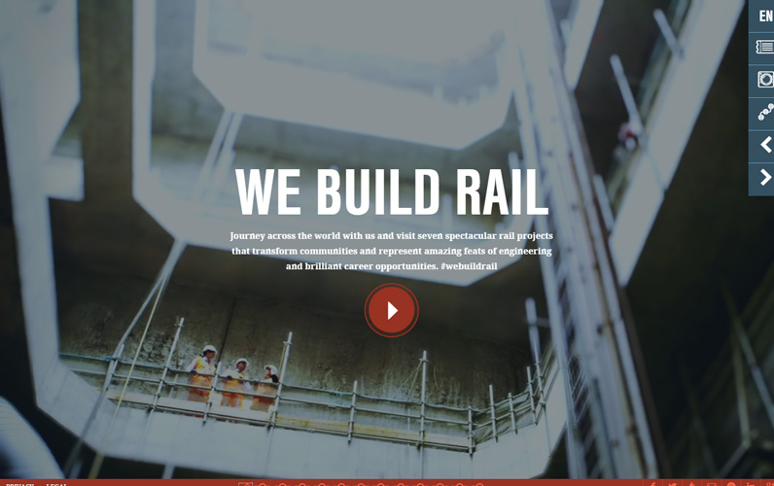
4 of 8: Betchel Rail

What we like about it: Great use of video to tell the story of the company. Professional quality and engineering. (View site in new tab)
< PREVIOUS |  | NEXT >

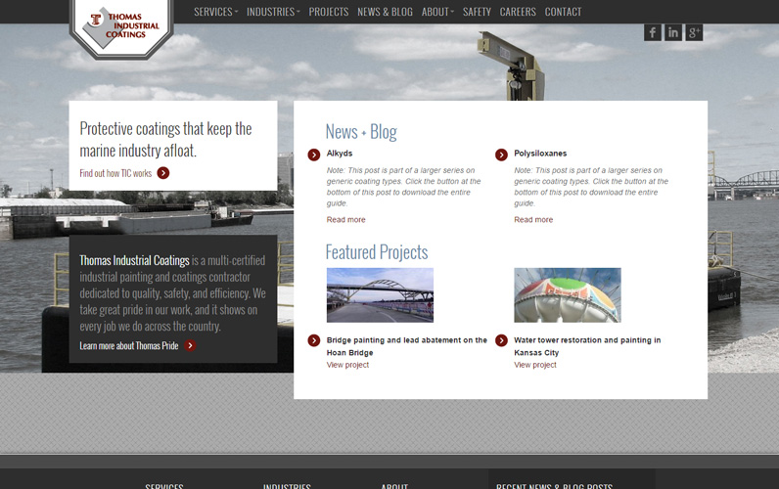
5 of 8: Thomas Industrial Coatings

What we like about it: Full screen layout with a simple home page. Easy navigation and responsive design. (View site in new tab)
< PREVIOUS |  | NEXT >

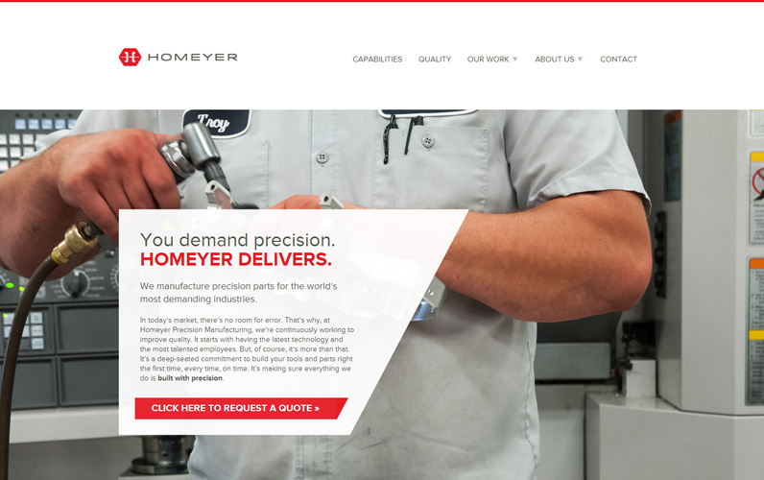
6 of 8: Homeyher Tool

What we like about it: Nice color choice of contrasting the red logo with neutral white and grey tones. Great utilization of geometric shapes, straight edge and sans-serif fonts to communicate a modern brand. (View site in new tab)
< PREVIOUS |  | NEXT >

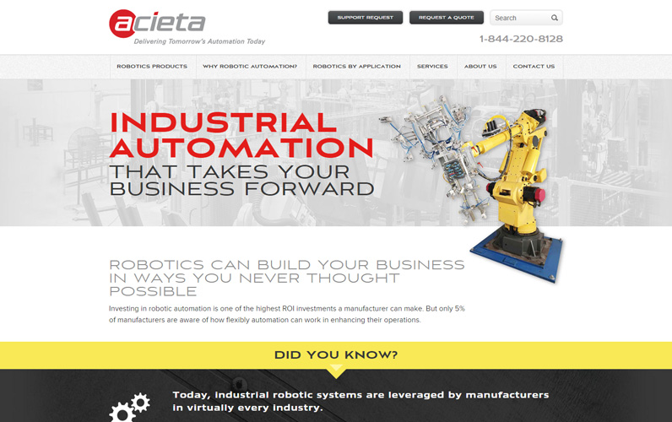
7 of 8: Acieta

What we like about it: Great utilization of black, red and yellow contrasting colors which flows with the product design. This website is also responsive. (View site in new tab)
< PREVIOUS |  | NEXT >

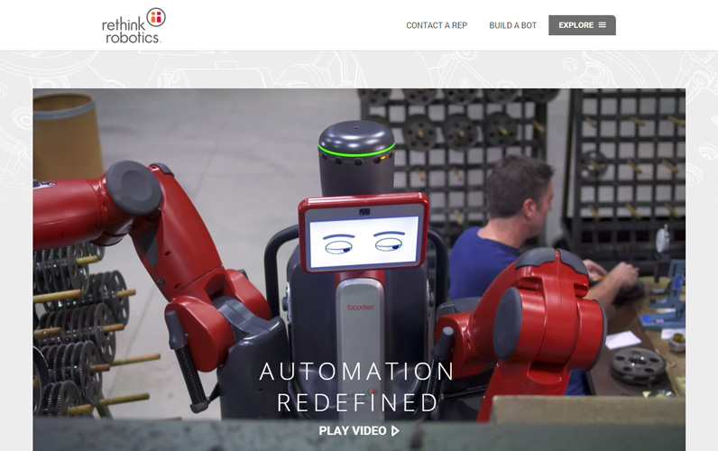
8 of 8: Rethink Robotics

What we like about it: The video says it all. (View site in new tab)
< PREVIOUS |  | NEXT >

Posted in: general, web design
Planning Your Website Re-Design Budget?
By using our web design budget planning calculator, find out how much you should expect to invest on a professionally built, marketing-ready industrial website. All in three minutes or less.
Get Pricing In Under 3 Minutes
https://verdemedia.com/web-design-price-estimator:
 Our Company; What We Do; Recent Work; Blog; Contact Us; Request Pricing


Get An Instant Website Price Estimate in 3 Minutes (or Less)
Very little, if any boutique web design agencies advertise their price online. We don’t blame them – there are just way too many variables to take into consideration when pricing out a custom web design project.
At Verde Media, however, we’ve got it down to a science. That’s why we’ve built this calculator.
The instructions are simple: drag the slider to answer each question. At the bottom, check the features that you think that you’ll need built into your new website. Then tell us some basic information about you and let us know where to send your price estimate.
Top of Form
- How many pages does your website need?
I need help answering this question
- How many people visit your website on a monthly basis?
I need help answering this question
- How much does being unique matter to you?
I need help answering this question
- What design style fits your brand the most?
I need help answering this question
- How Important Is Lead Generation To You?
I need help answering this question
- How important is expandability to you?
I need help answering this question
- What other features do you need with your new website?
I need help answering this question
E-Commerce Cart
CRM Integration (Salesforce, Nutshell, etc.)
Marketing CMS Integration (HubSpot, Marketo, etc.)
E-Mail Marketing (Mailchimp, ConstantContact, etc.)
Custom API Development
Simple User Login & Dashboard
Other



You’re 36 Seconds Away From Getting Your Price
Just tell us your name, the name of your organization, and where to e-mail your estimate. It will be sent instantenously.
What Is Your Name?*
What is Your Company / Organization's Name?*
Tell Us Where To Email Your Price Estimate*


READY TO GET STARTED ON BUILDING YOUR DREAM WEBSITE?
SCHEDULE A FREE CONSULTATION TODAY

